**Test Cases**

1. To create:
   1. 2 guests occupied each room type (single, standard, VIP, suite, deluxe) with different details.

* Single

Before 2 guest check-in

After 2 guests check-in 

* Double

Before 2 guests check-in

  
After 2 guests check-in

* 1. 2 rooms of each room availability status ‘Under Maintenance’



* 1. 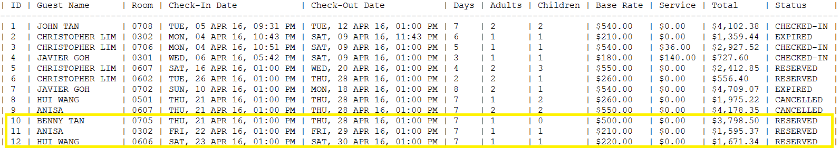3 reservations with corresponding different guest details with check-in date set as 1 week later
  2. 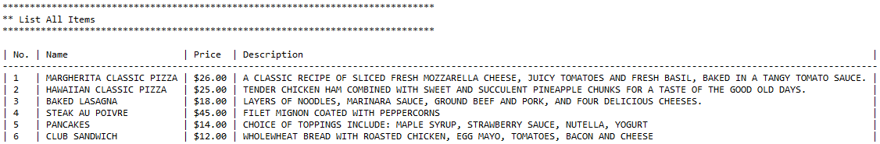At least 5 room service menu items

1. Search for a guest and list its details:
   1. 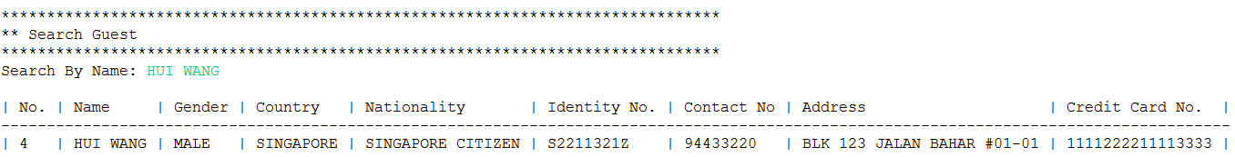Found
   2. 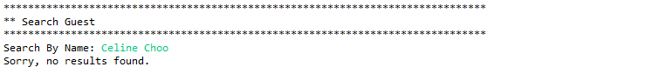Not found

c. Update a guest’s credit card detail

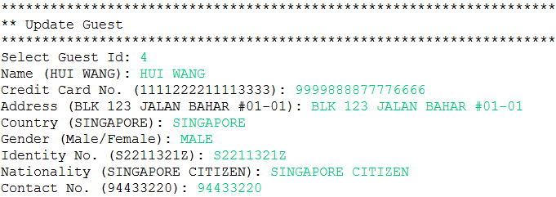

1. ****Search for this guest and list its details

As seen from previous screenshot, Hui Wang’s credit card number was 1111222211113333.

1. 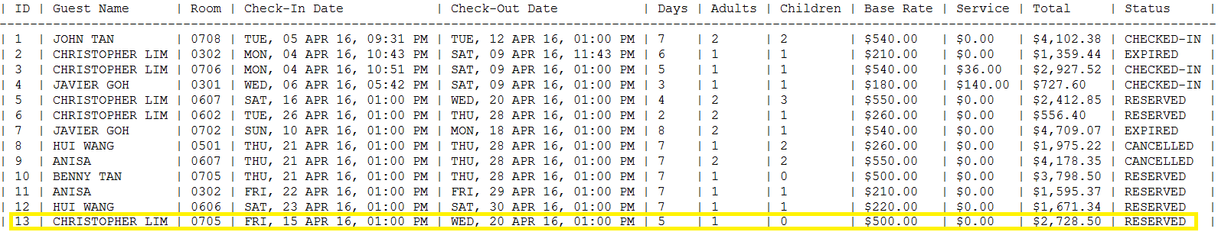Create a reservation with check-in date set as 1 day later

1. 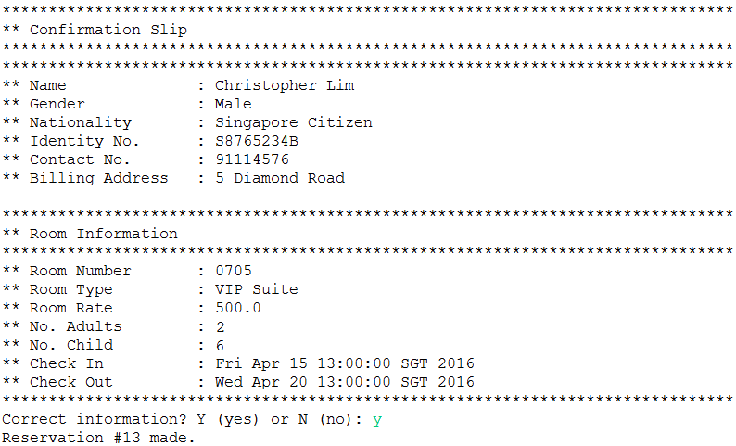After confirmation, acknowledgement receipts is printed with details and room status changed to ‘Reserved’



1. 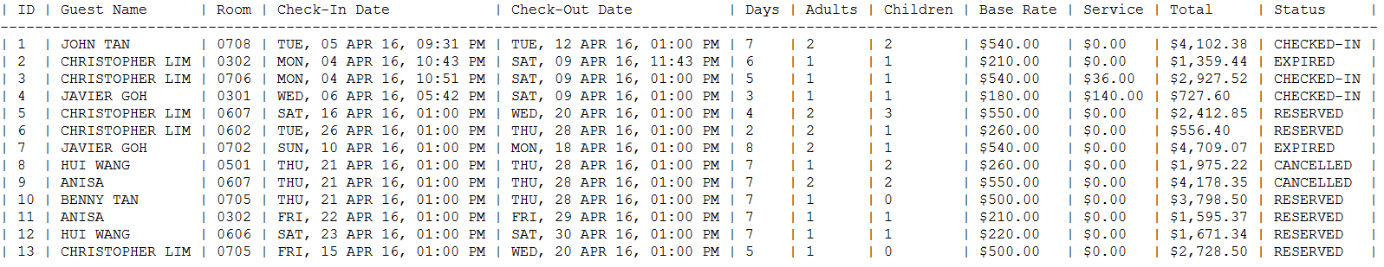Print all reservations

note: room status will expire if guest do not check in by 1400hrs on the check-in date

1. Update the price of a room service menu item



1. Enter room service order
   1. Reflect above change in price

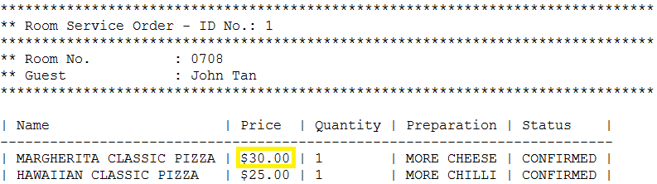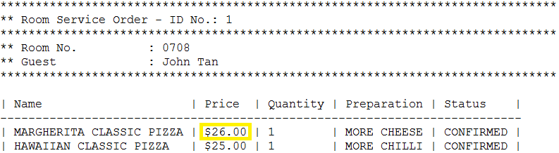

1. 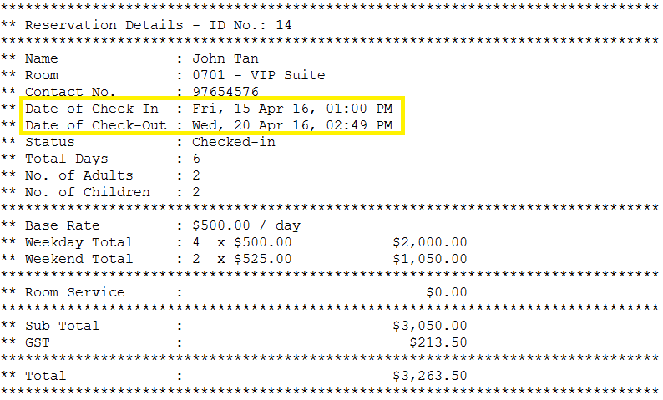Room Check-out and print bill [change system date to show 6 days of stay]

1. Check availability of a room [above room should be available]
2. 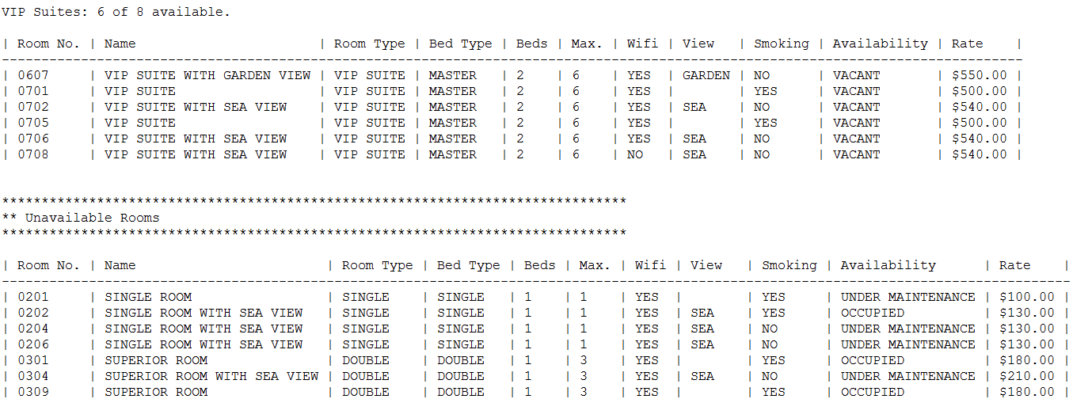Rooms availability for the day

Note: Rooms ‘Availability’ will show Reserved if guest makes a reservation on that day.